**Somate Contract Test Report**

**Since**: Saturday, November 20, 2021

**Author**: David

**Version**: 1

1. **Pass Solmate proj info to the contract**

Config info to be passed on Js side:

exports.config = {

    stake_min_days: 7,

    stake_max_days: 365,

    emission_total_days: 365*2,

    total_supply: 1000000000,

    ciety_decimals: 9,

    ciety_symbol: '$CIETY',

    ciety_name: 'Ciety',

    to_community_percent: 0.2,

    to_community_address: '9d3NMTLcKF6MLiVAjQ3bv76yqarpw7VxkAbGvqYmxV3k',

    to_team_percent: 0.05,

    to_team_addresses: ['9d3NMTLcKF6MLiVAjQ3bv76yqarpw7VxkAbGvqYmxV3k', '9d3NMTLcKF6MLiVAjQ3bv76yqarpw7VxkAbGvqYmxV3k'],

    to_rewards_percent: 0.75,

    start_emission: 100000

}

Decoded info on the contract side:

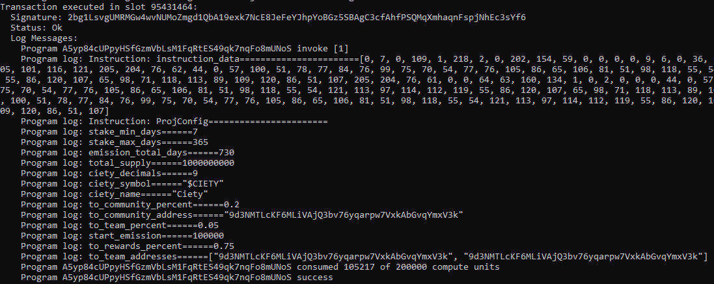

1. **Prep $CIETY and held in some account**

Addresses on Js side:

$CIETY mint addr=== 5zCg63F5Dt3ZecdTMeH9pytj8RD2z5zgC2ygyTvhQUJA

$CIETY account addr=== 76CGtfusBX3MSD7PN5va3idujjUQo23SA232rigsSG9t

Related info on Solana Explorer:

Token Mint,

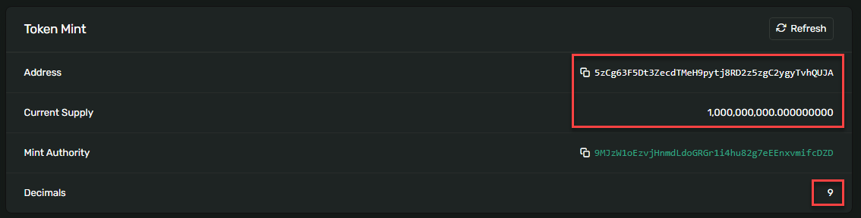

Account:

